**Experiment Name:**

Write a program that takes a hex number of 4 digit or less as input and outputs its binary on the next line and count the number of 1's in its reversed binary number.

**Theory:**

The objective of this program is to convert a hex number into 16 bit binary number and then reversing that binary number, the number of 1’s need to be counted and printed in the output. For this program in assembly, loops, JMP instructions and some registers need to be used.

**Code:**

.STACK 100H

.MODEL SMALL

.DATA

M1 DB 0AH,0DH,'TYPE A HEXA NUMBER (0 - FFFF) : ','$'

M2 DB 0AH,0DH,'IN BINARY IT IS : ','$'

M3 DB 0AH,0DH,'ILLEGAL HEXA DIGIT, TRY AGAIN :','$'

M5 DB 0DH,0AH,'REVERSE : $'

M4 DB 0AH,0DH,'THE NUMBER OF 1 BIT IN ITS REVERSE IS '

C2 DB 0,'$'

.CODE

MAIN PROC

MOV AX,@DATA

MOV DS,AX

MOV AH,9

LEA DX,M1

INT 21H

START :

XOR BX,BX

MOV CL,4

MOV AH,1

INT 21H

WHILE_:

CMP AL,0DH

JE END_WHILE

CMP AL,'0'

JL ERROR

CMP AL, '9'

JG LETTER

AND AL,0FH

JMP SHIFT

LETTER:

CMP AL,'F'

JG ERROR

CMP AL,'A'

JL ERROR

SUB AL,37H

SHIFT:

SHL BX,CL

OR BL,AL

INT 21H

JMP WHILE_

END_WHILE:

MOV AH,9

LEA DX,M2

INT 21H

MOV CX,16

MOV AH,2

SHOW:

ROL BX,1

JC ONE

MOV DL,'0'

INT 21H

JMP LOOP1

ONE:

MOV DL,'1'

INT 21H

ADD C2,1

LOOP1:

LOOP SHOW

MOV AH,9

LEA DX,M5

INT 21H

MOV CX, 16

MOV AH,2

REVERSE:

SHR BX,1

JC ONEE

MOV DL,'0'

INT 21H

JMP LOP1

ONEE:

MOV DL,'1'

INT 21H

LOP1:

LOOP REVERSE

JMP OUT_

ERROR:

MOV AH,9

LEA DX,M3

INT 21H

JMP START

OUT_:

ADD C2,30H

MOV AH,9

LEA DX,M4

INT 21H

MOV C2,0

MOV AH,4CH

INT 21H

MAIN ENDP

END MAIN

**Output:**

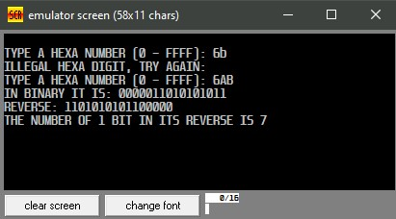

**Discussion:**

In the above program, a hexadecimal number was taken as input using a loop. In the loop CMP instructions were used to check the correction of the hex number and if it was not correct then, JMP was used to jump to another block named ERR where error message was printed. After taking the input, using Left Shift and Right Rotate and Hexadecimal number was converted into 16-bit binary number. After the conversion, it was reversed using Right shift with the help of loop. Then a variable C2 was used to count the occurrence of 1s in that 16-bit binary stream and that number was printed finally.